

Hosted Challenge App

Data Analytics and Artificial Intelligence Tools 2 (Gpo 101)

Team: Le Frites

Names and IDs:

Humberto Gonzalez Escamilla - A00837328
Arath Mendivil Mora - A01660670
Lázaro Rodríguez Bedolla - A00838171
Marius Ismael Calves - A01831309
Andrés Montemayor Tatum - A01383664

November 30, 2025
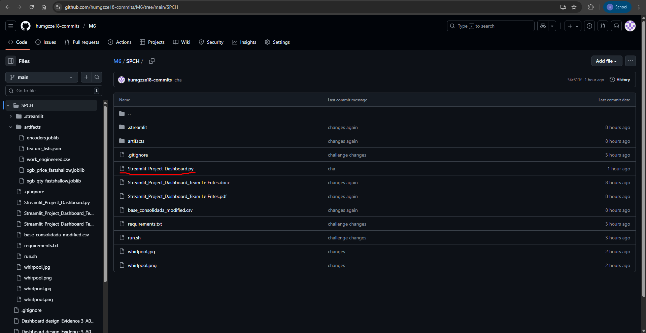
Screenshot of the GitHub Repository and the link to access it.
Link: https://github.com/humgzze18-commits/M6/tree/main/SPCH

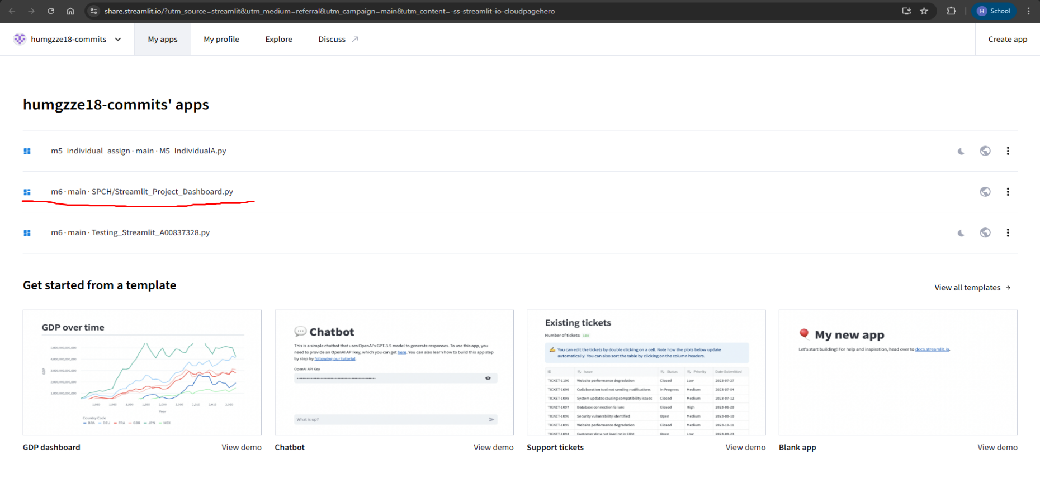
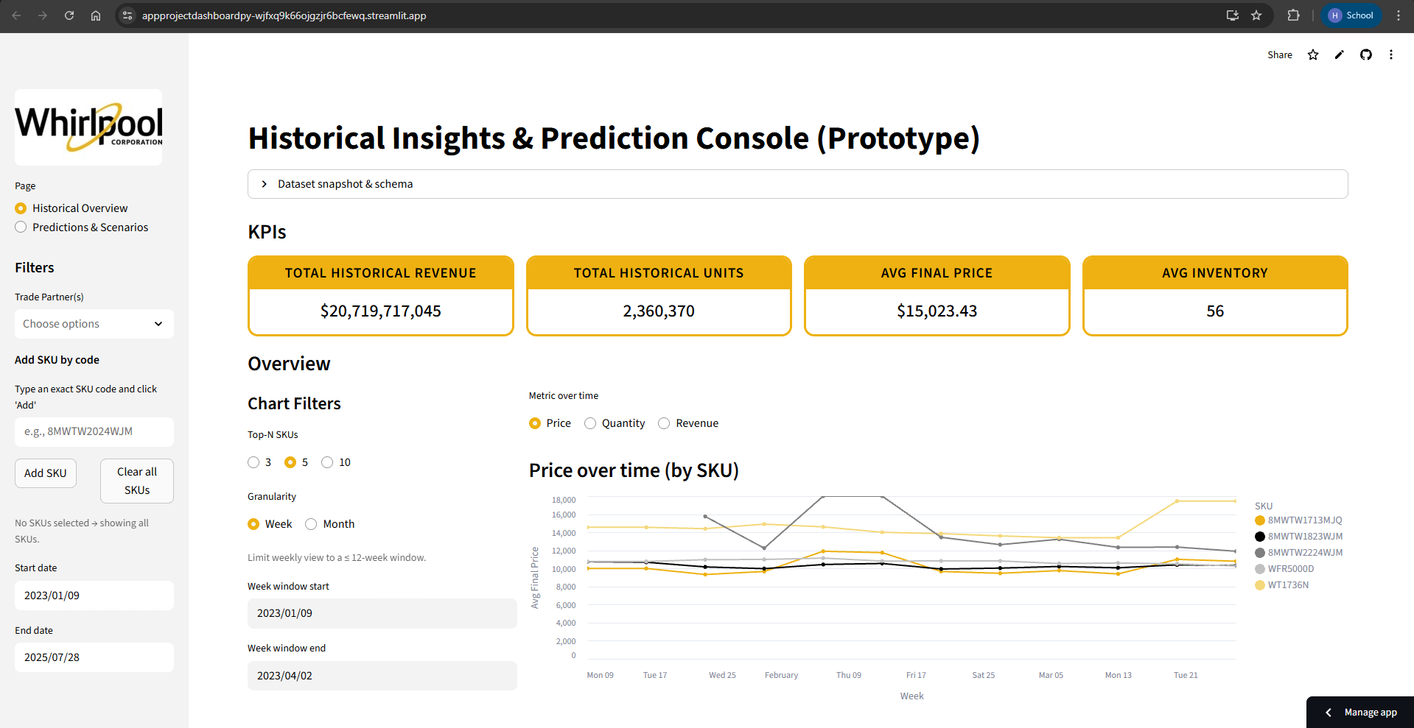
Screenshot of the app deployed and the link to access it.
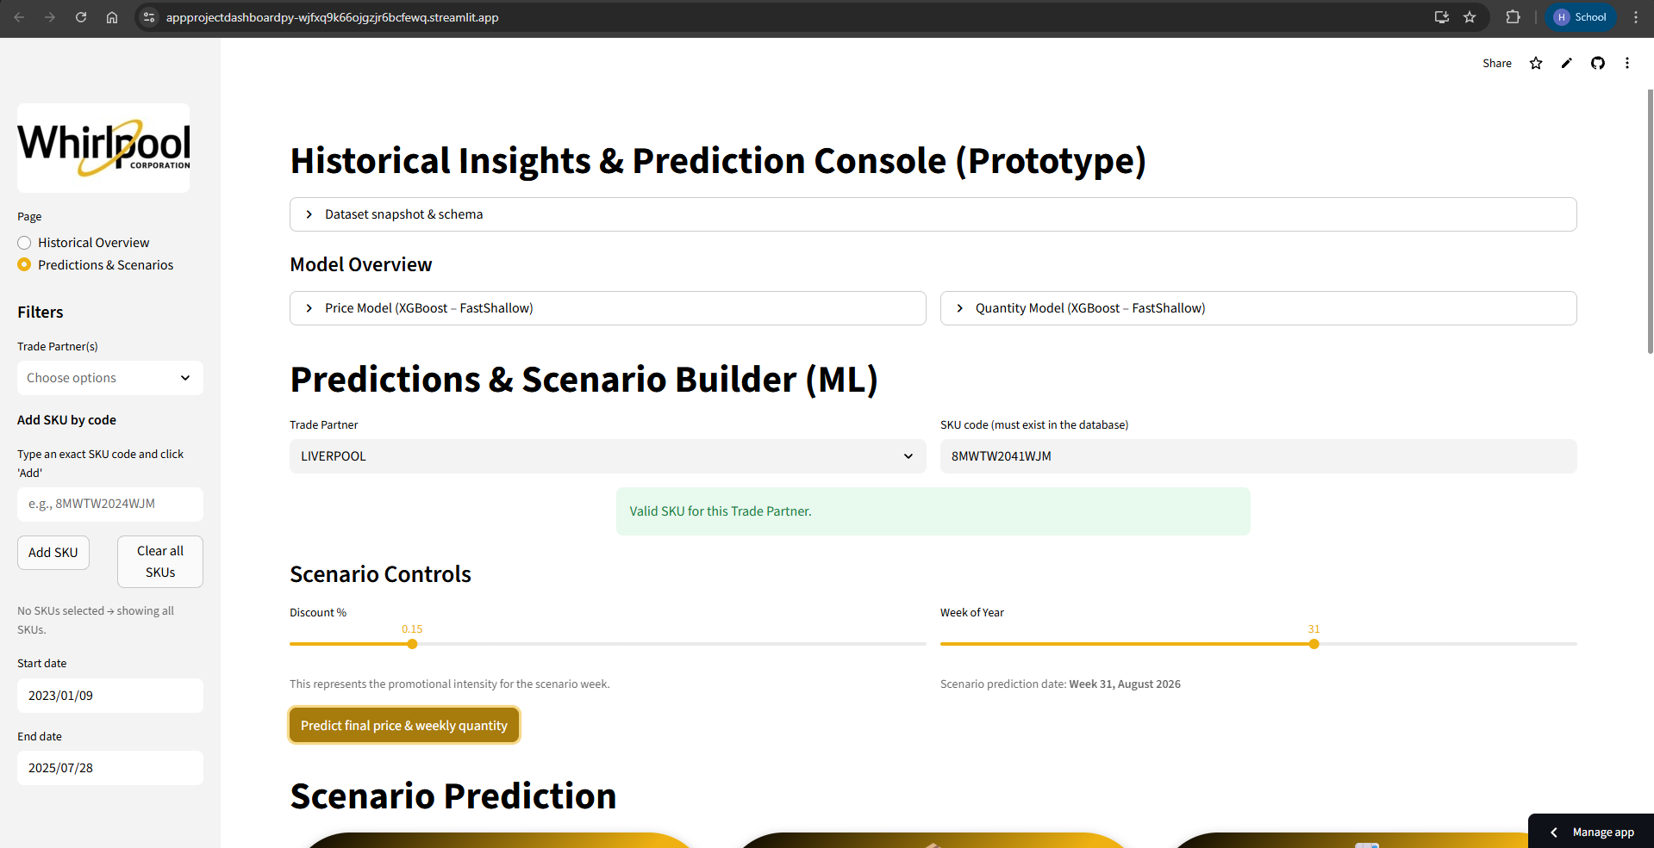
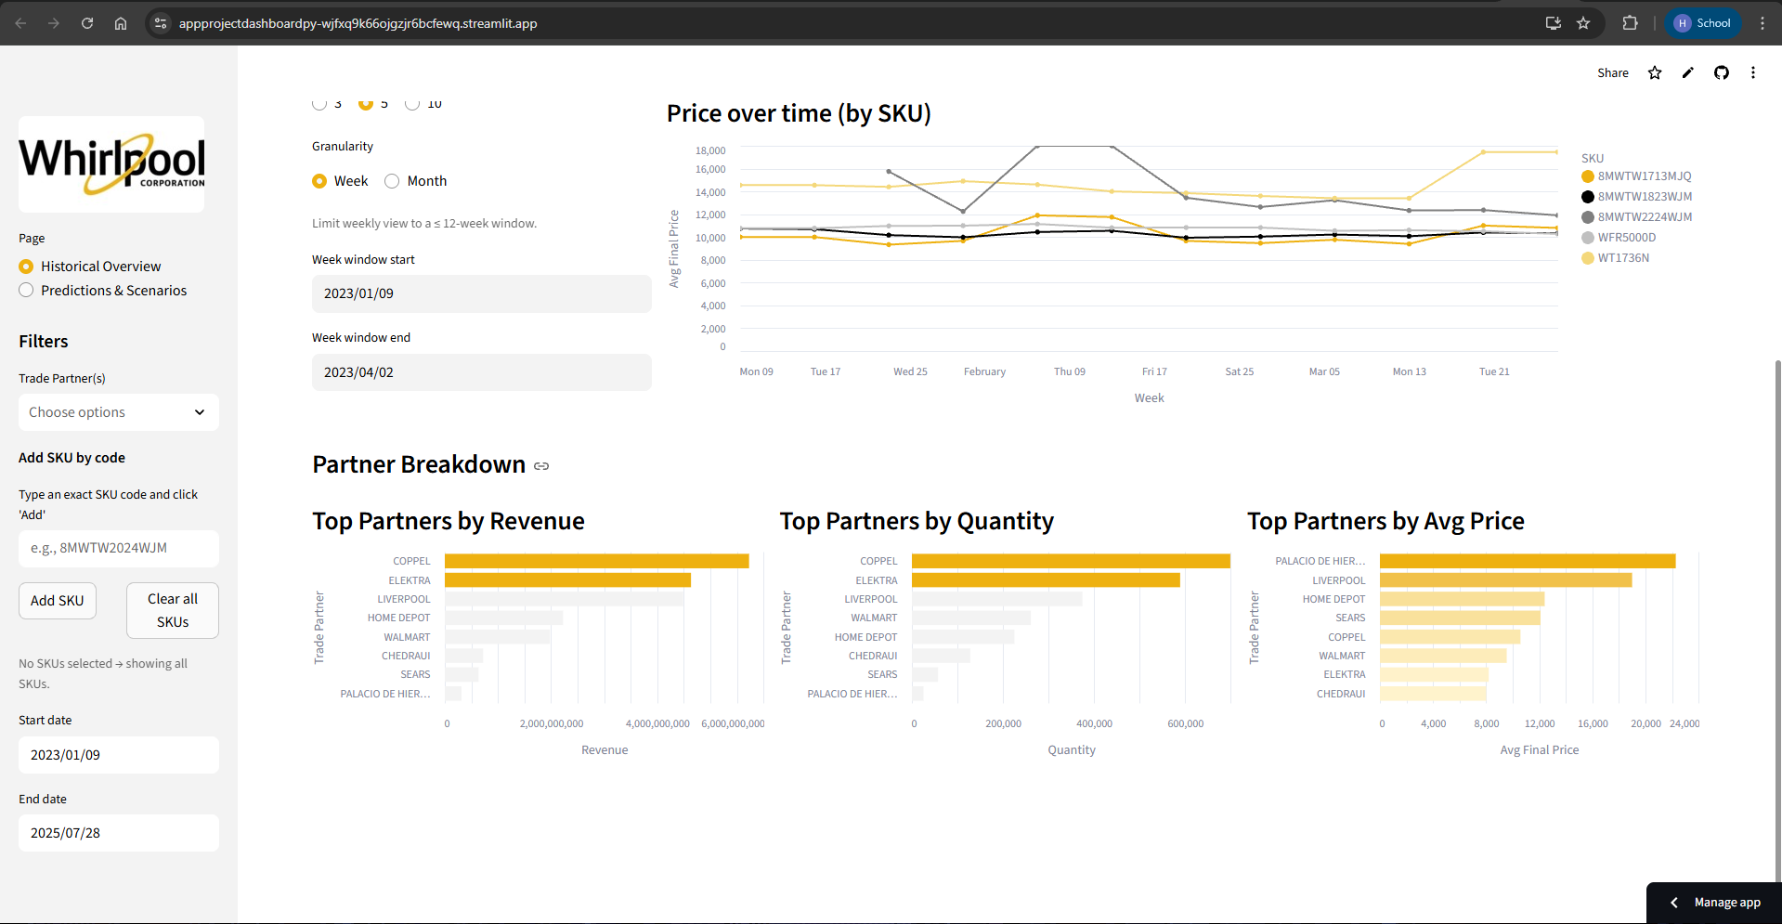
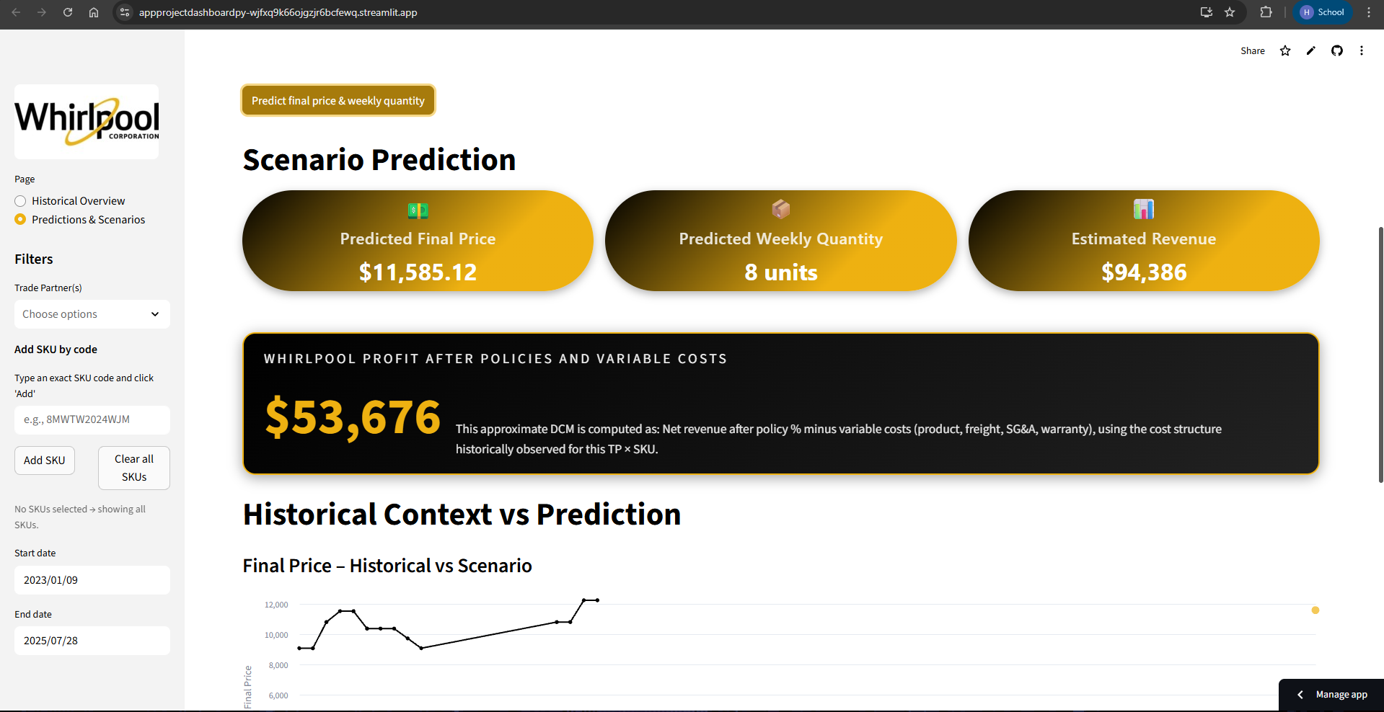
Link: https://appprojectdashboardpy-wjfxq9k66ojgzjr6bcfewq.streamlit.app/

